INSTALLATION OF KUBERNETES BY USING KOPS IN AWS

For this project we need

1. Aws account and
2. Domain name

For purchase domain name we need to sign in to Godaddy

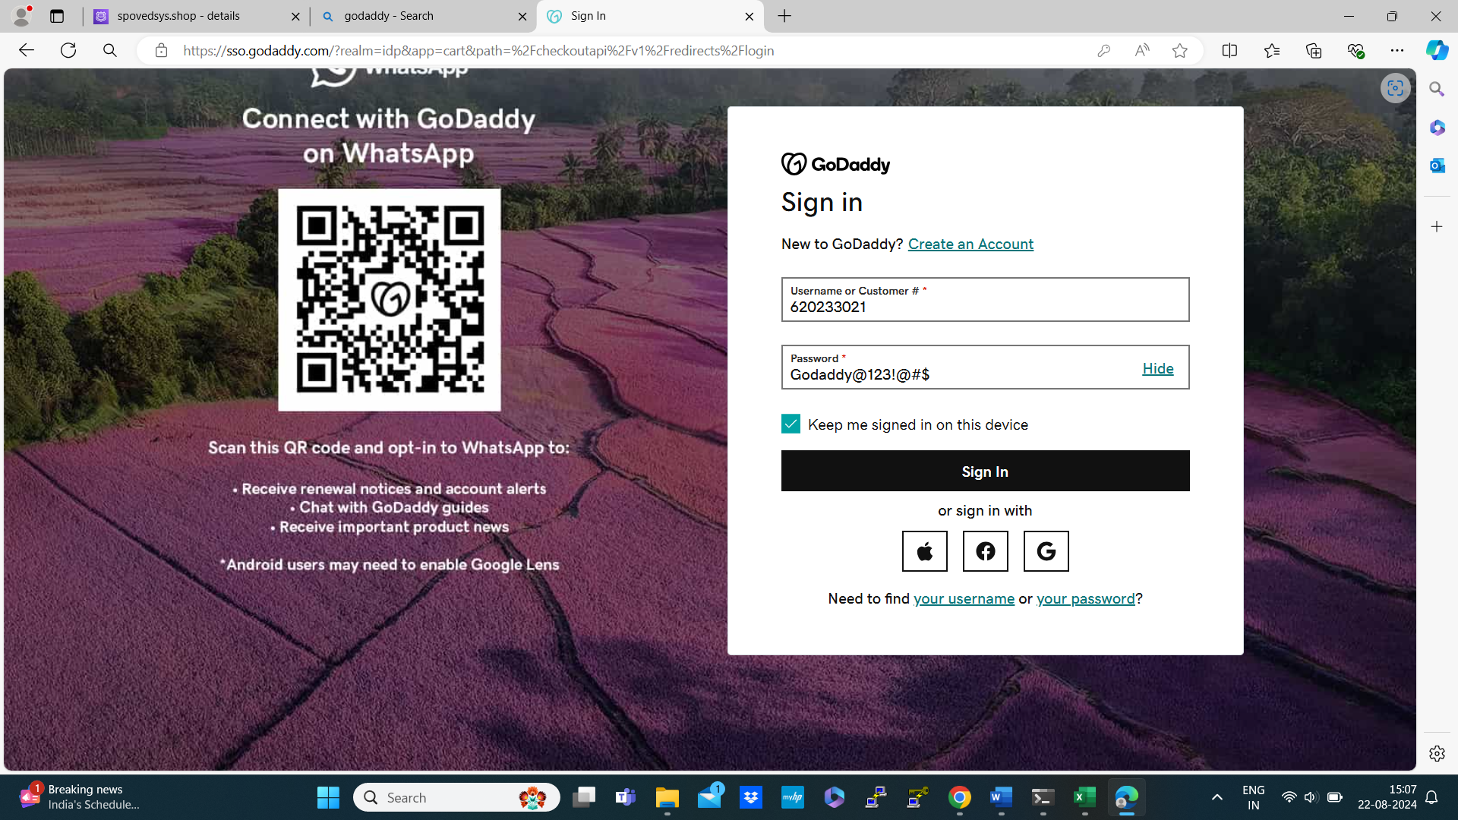



This web interface will appear

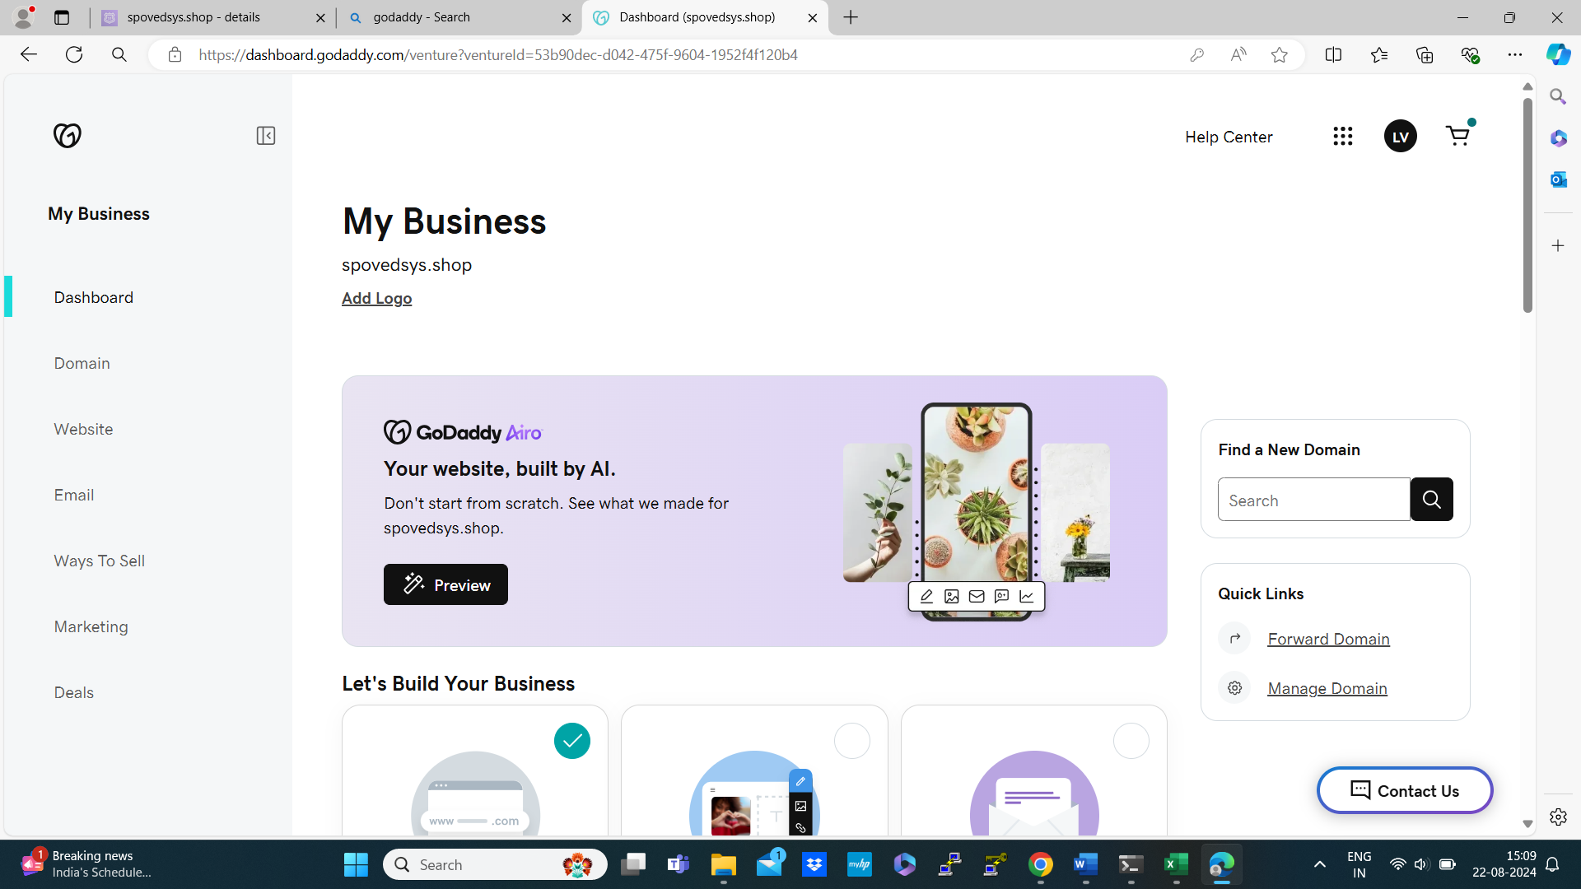

Then navigate to domain

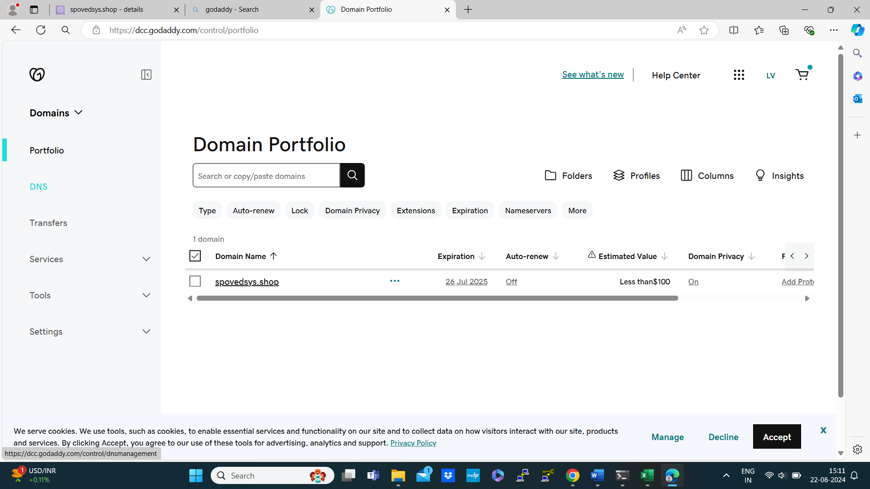

This is my DNS name spovedsys.shop

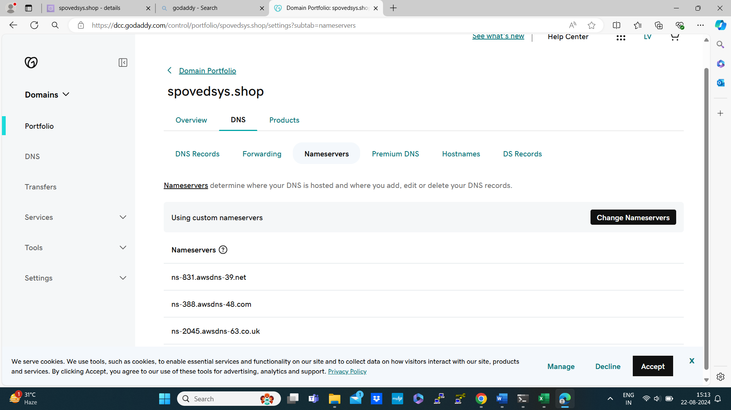

For DNS Name purchasing process refer documentation or video guide from internet

Now its time to change the name servers for that login to aws management console

Navigate to Route53 🡪Hosted zones 🡪 create Hosted zones

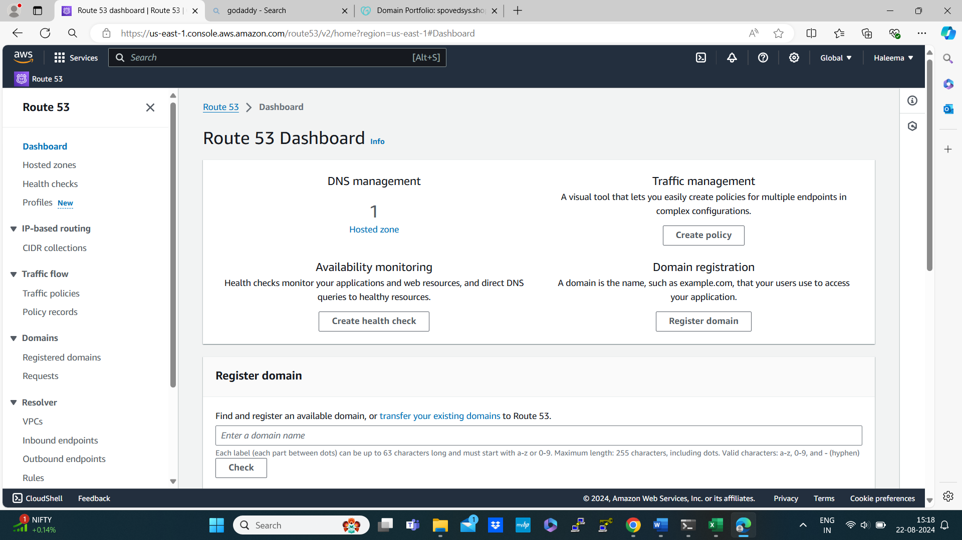

Create Hosted Zone

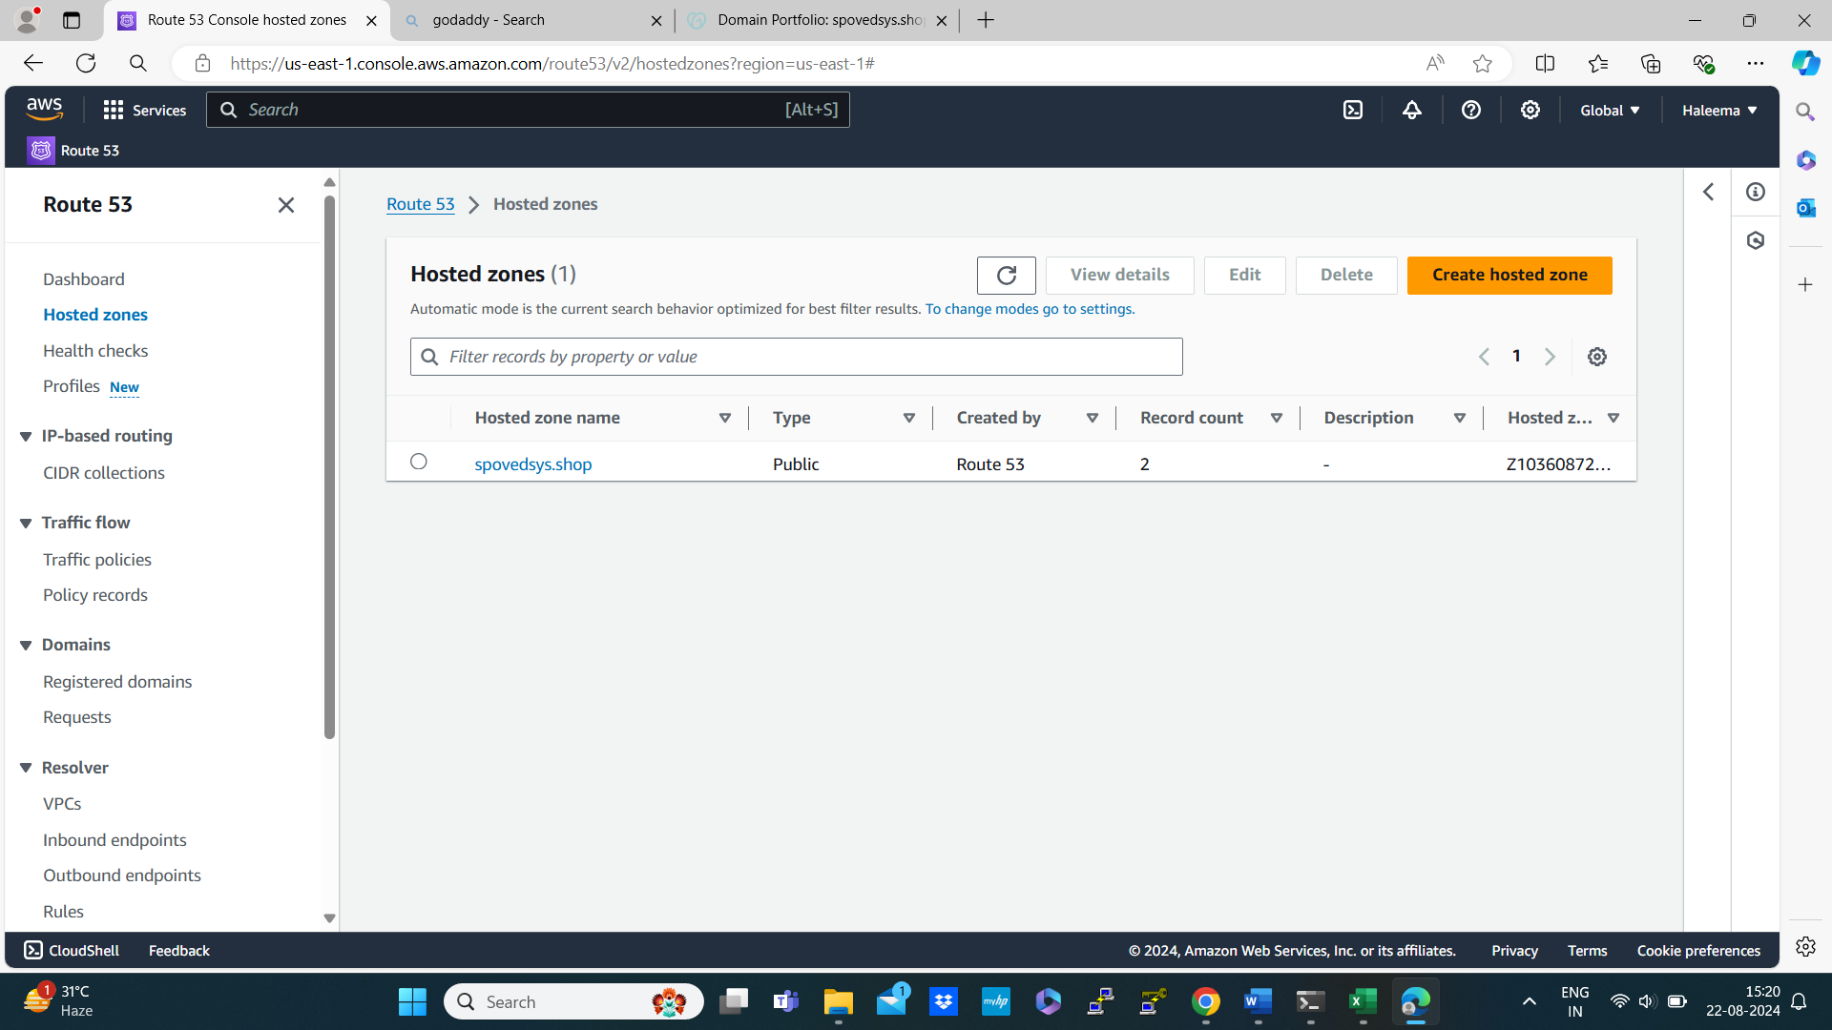

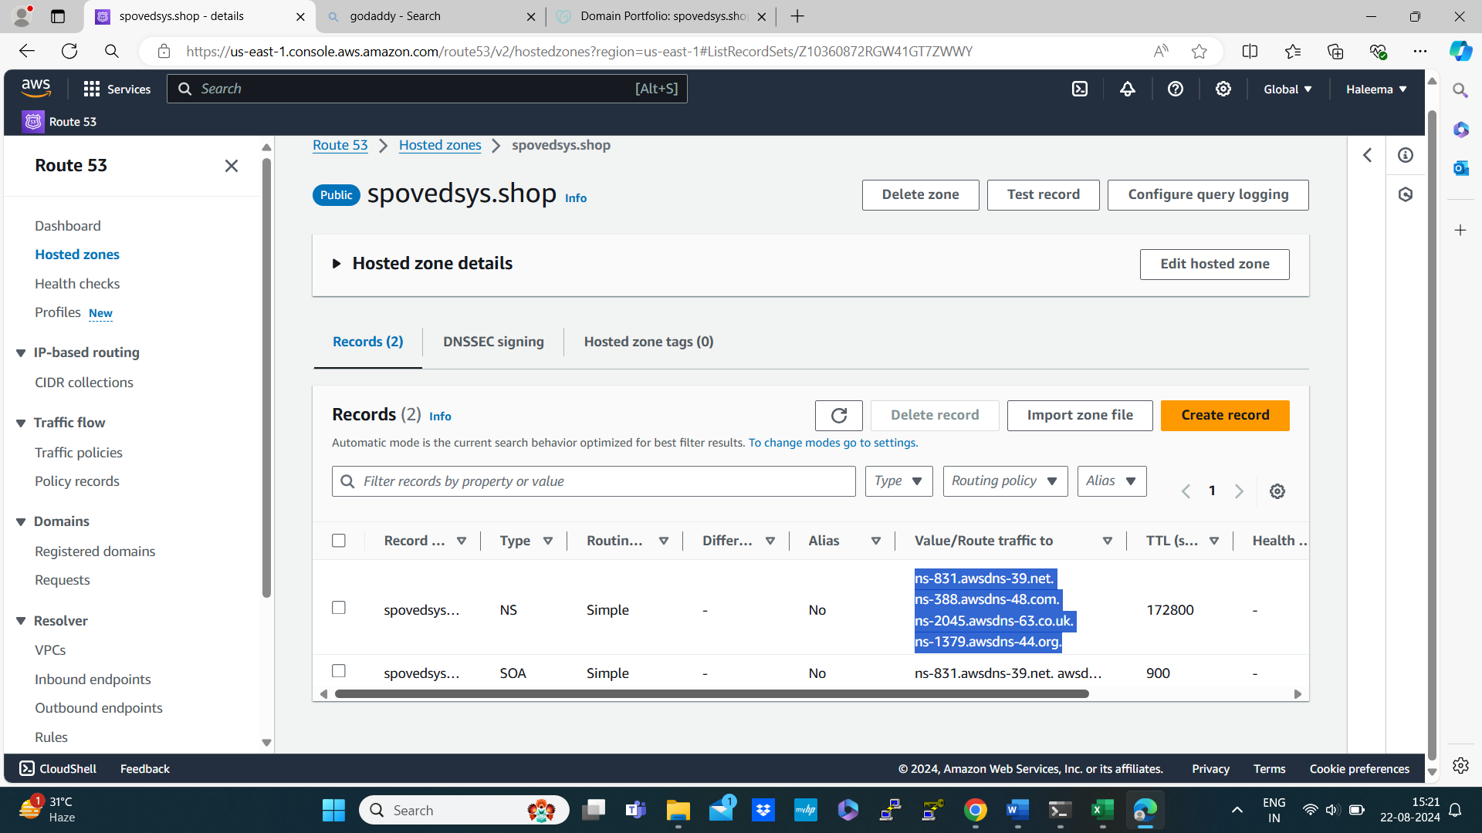

Copy value/route traffic to past it in the place of Name server



Then create s3 bucket using domain name for backup

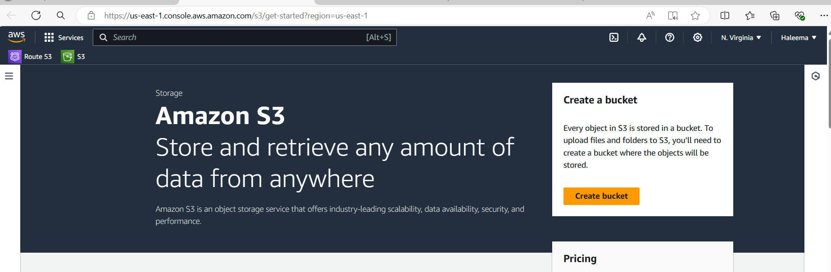

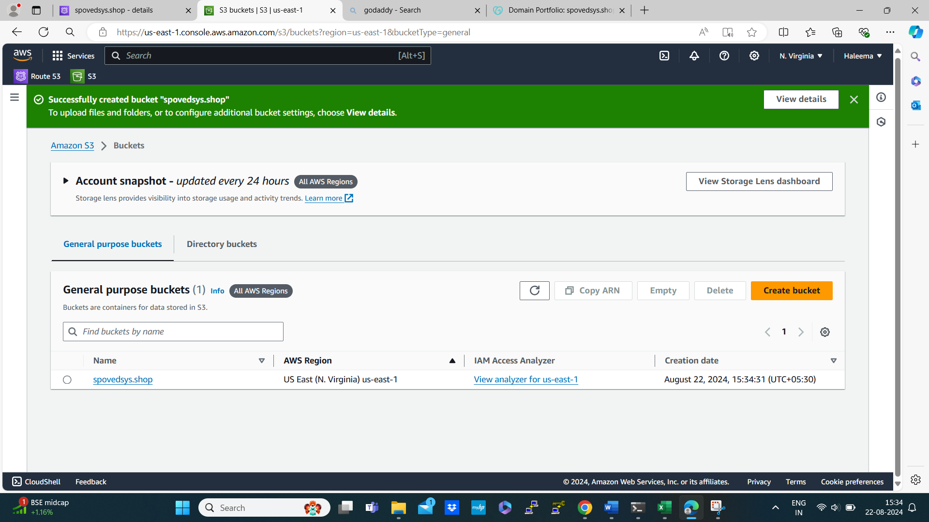

Create aws iam role name it as kops-role with the below mentioned 8 permission

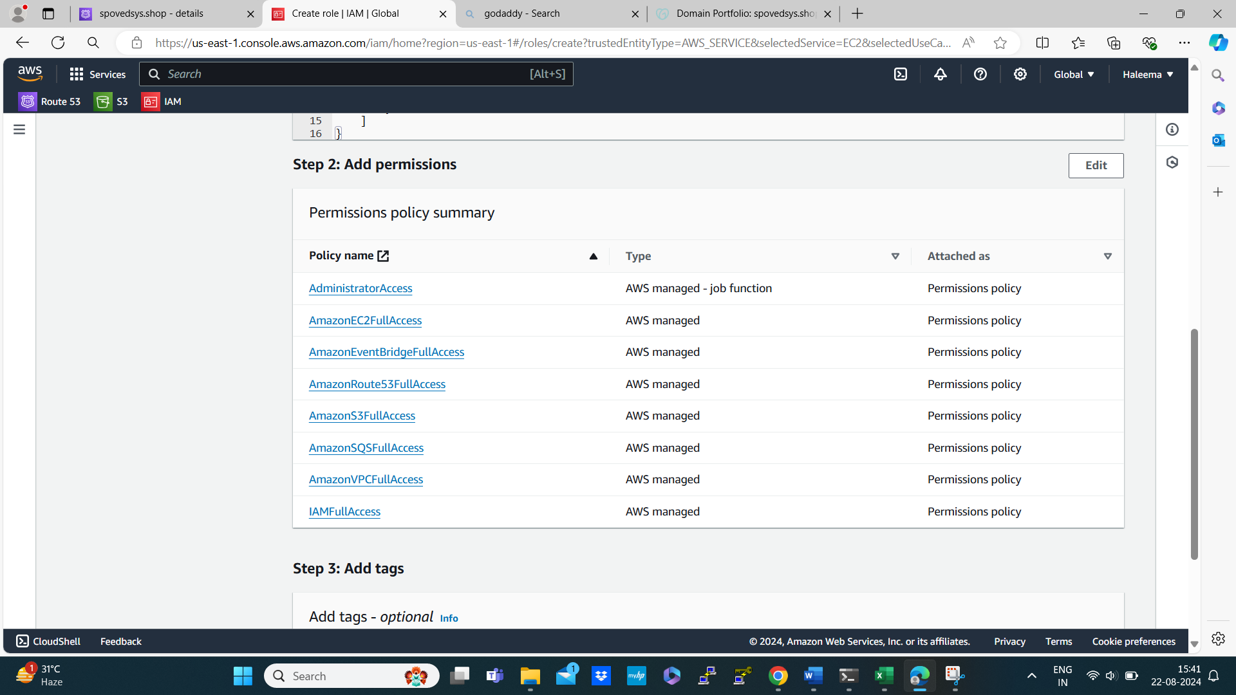

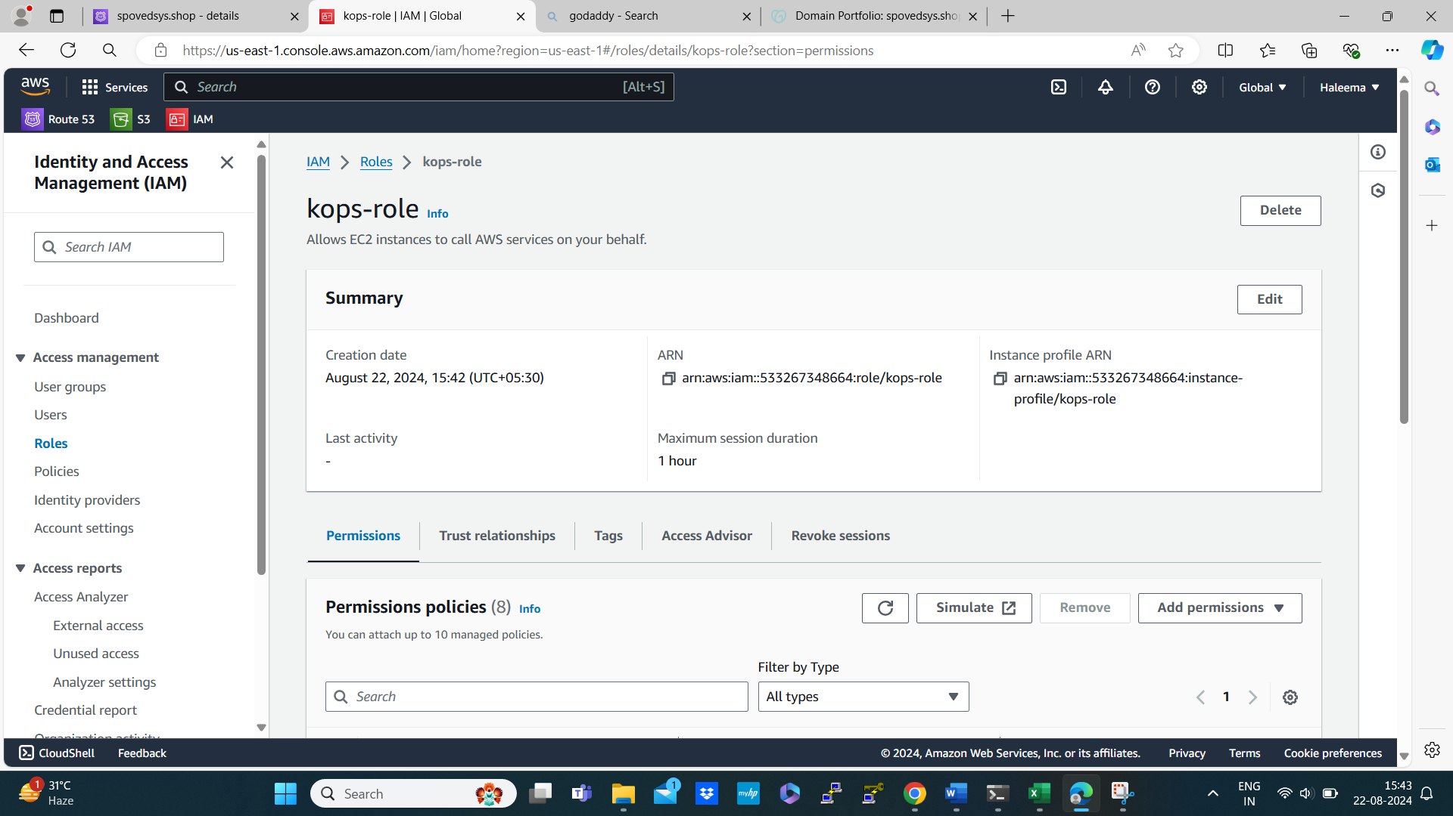

Role created successfully

Now create vpc for that navigate to vpc in the aws management console

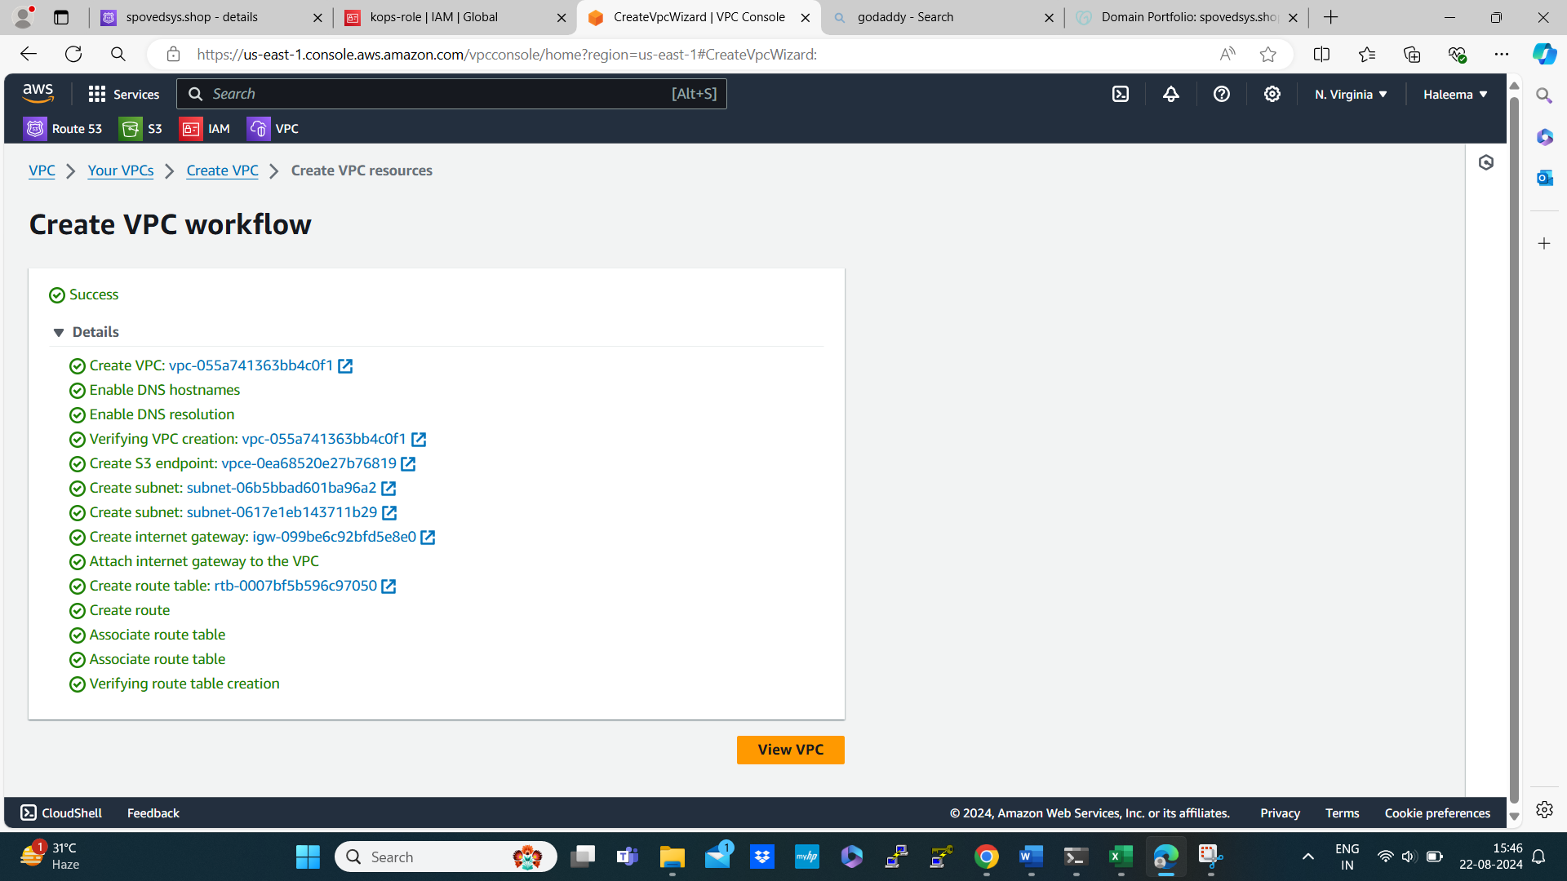

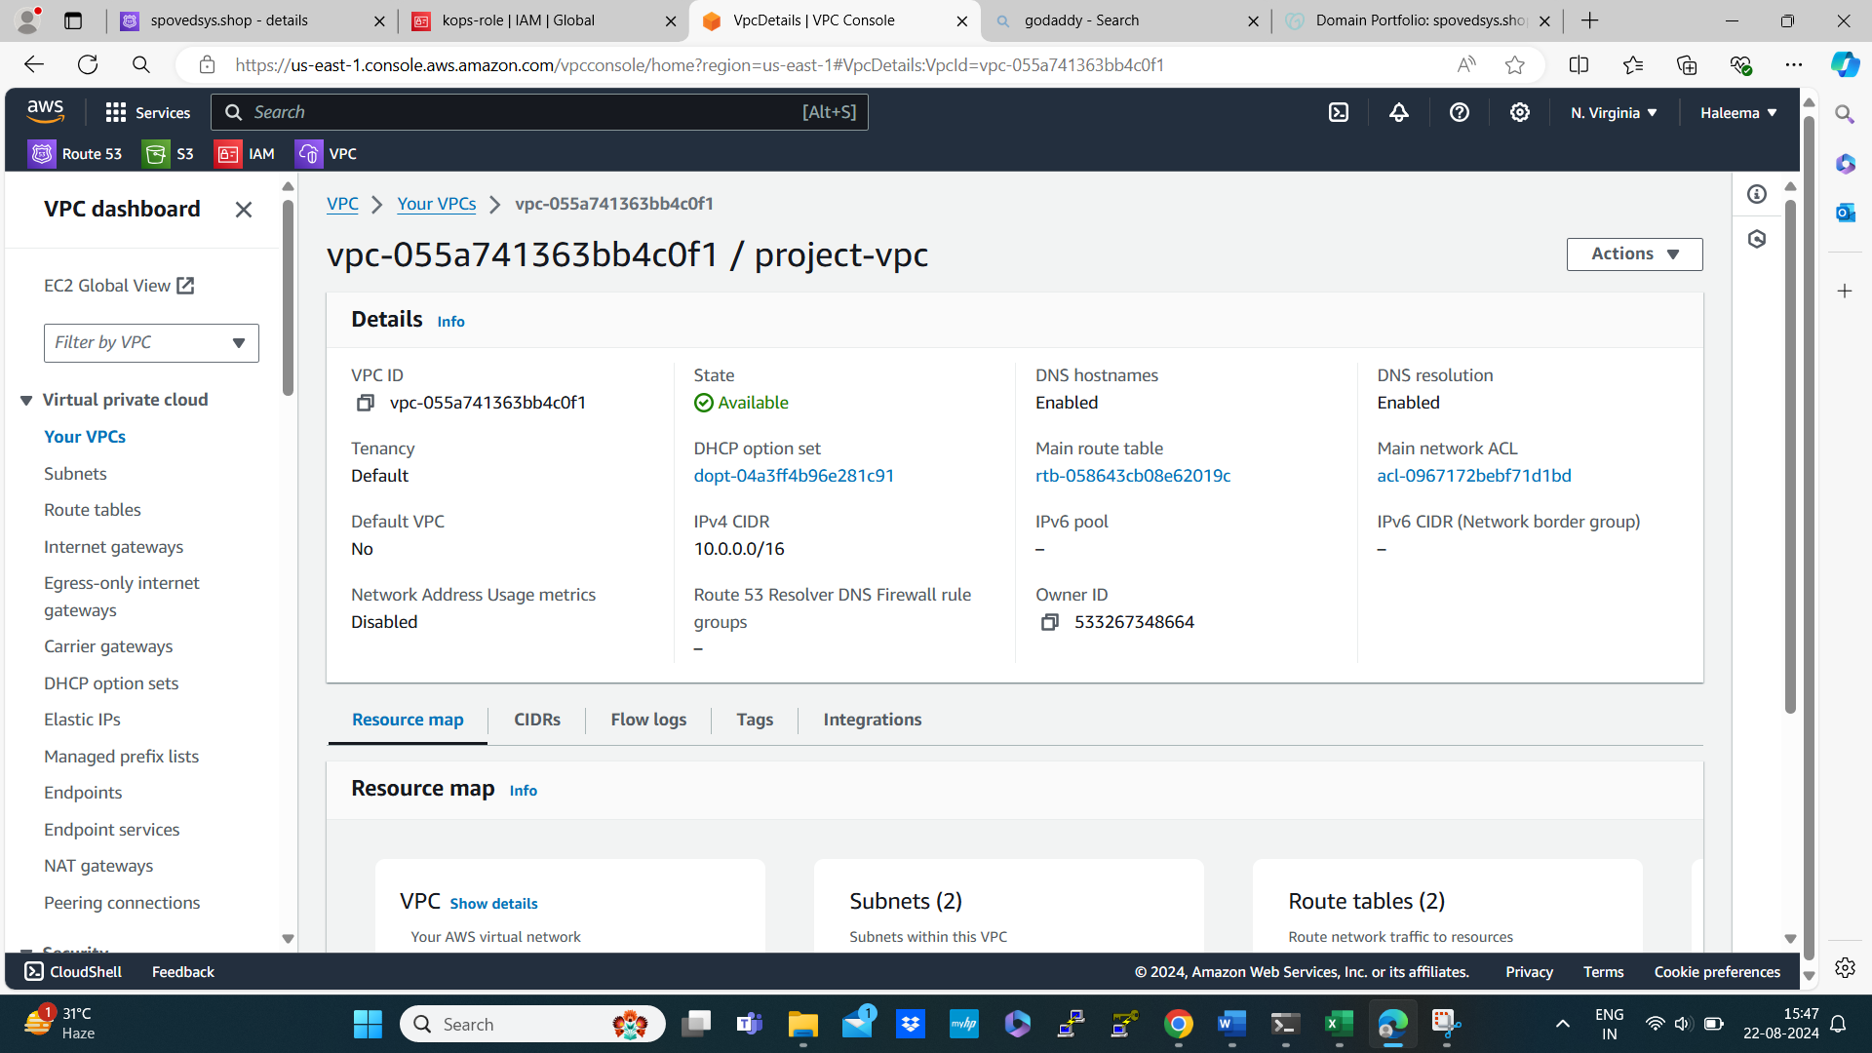

By using this vpc launch an instance

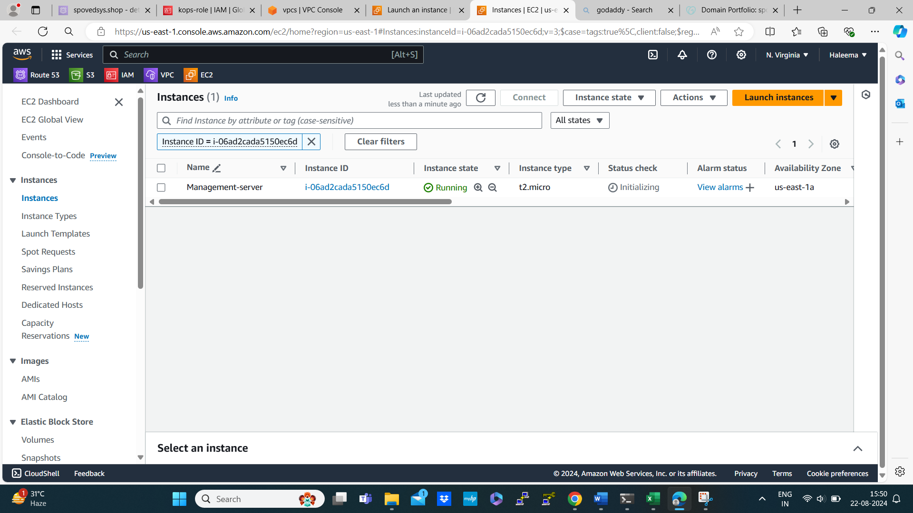

Attach the IAM role to the management-server

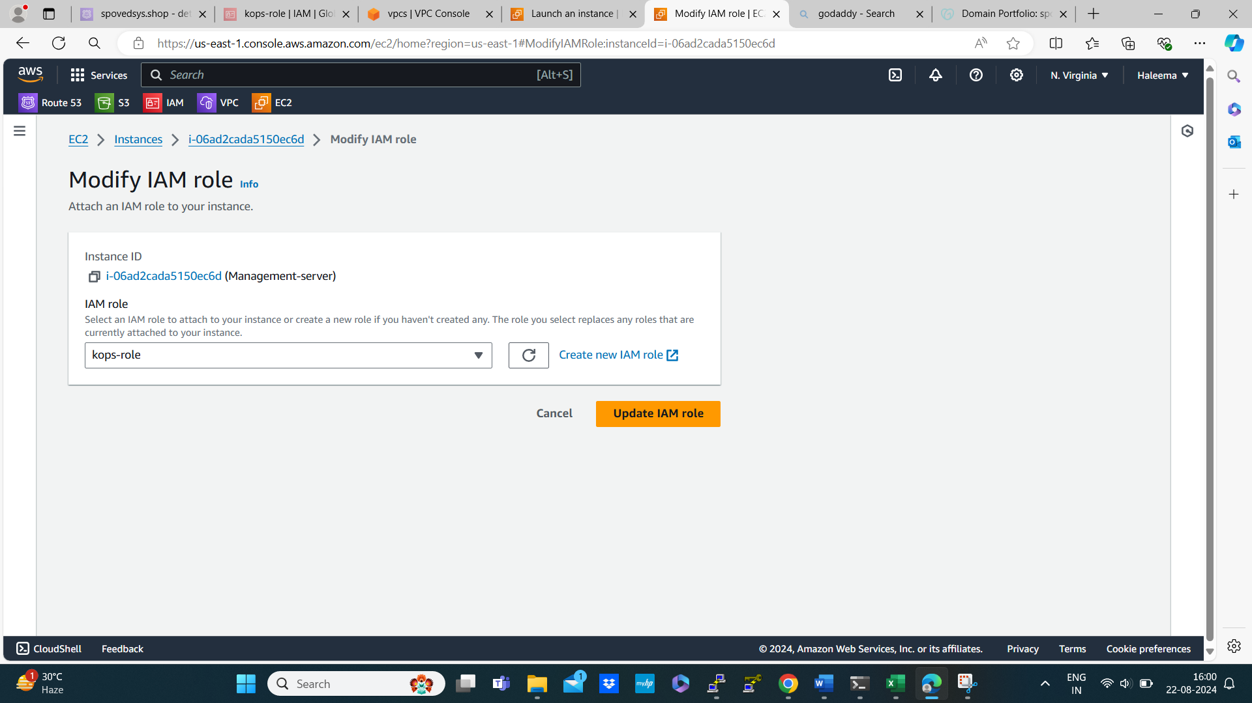

Then connect this instance using putty

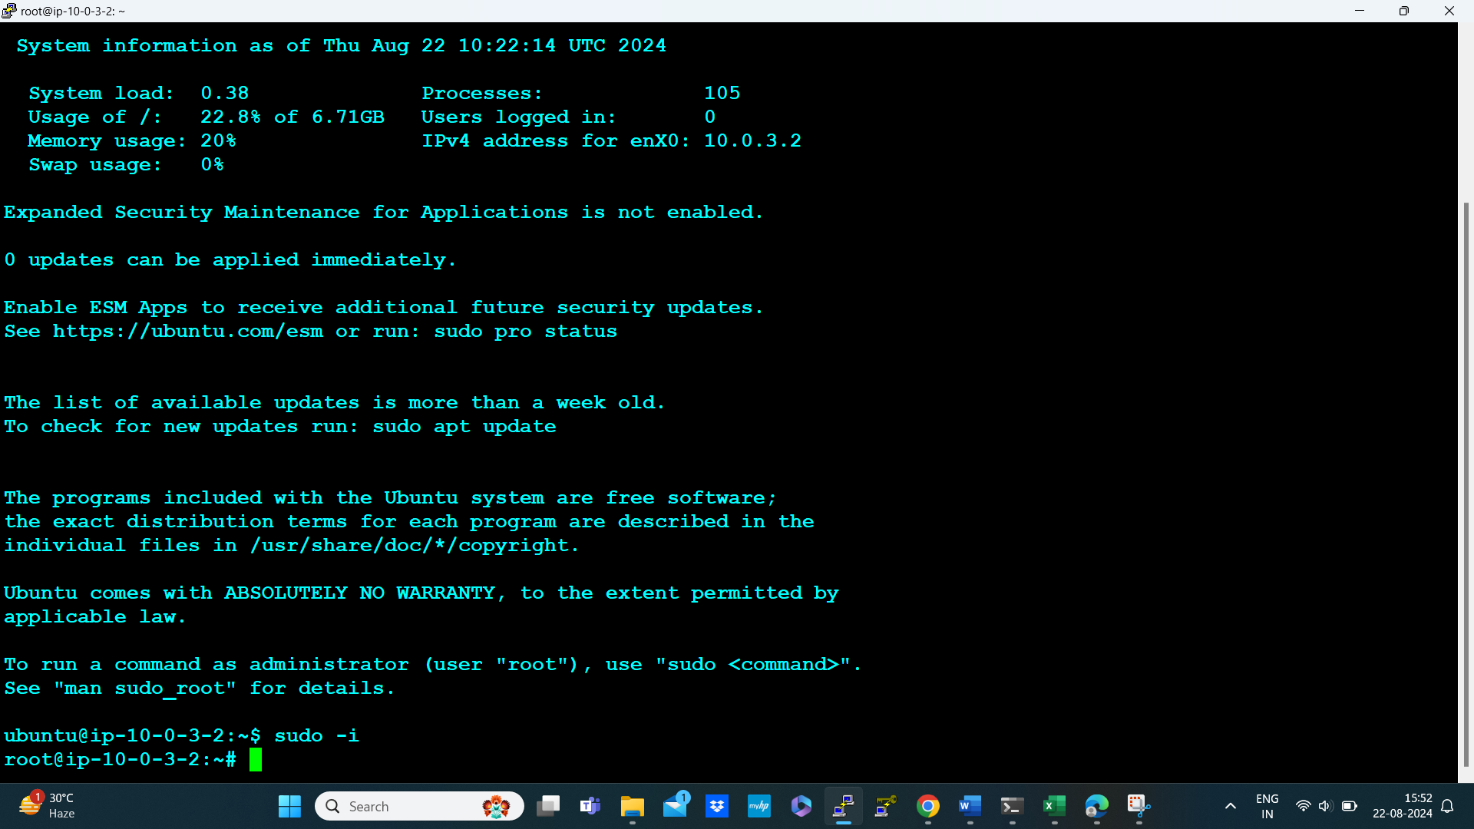

Then sudo -i to become root user

Then update the machine apt-update -y

Generate key using the command # ssh-keygen -t rsa

# cd .ssh/ # ll

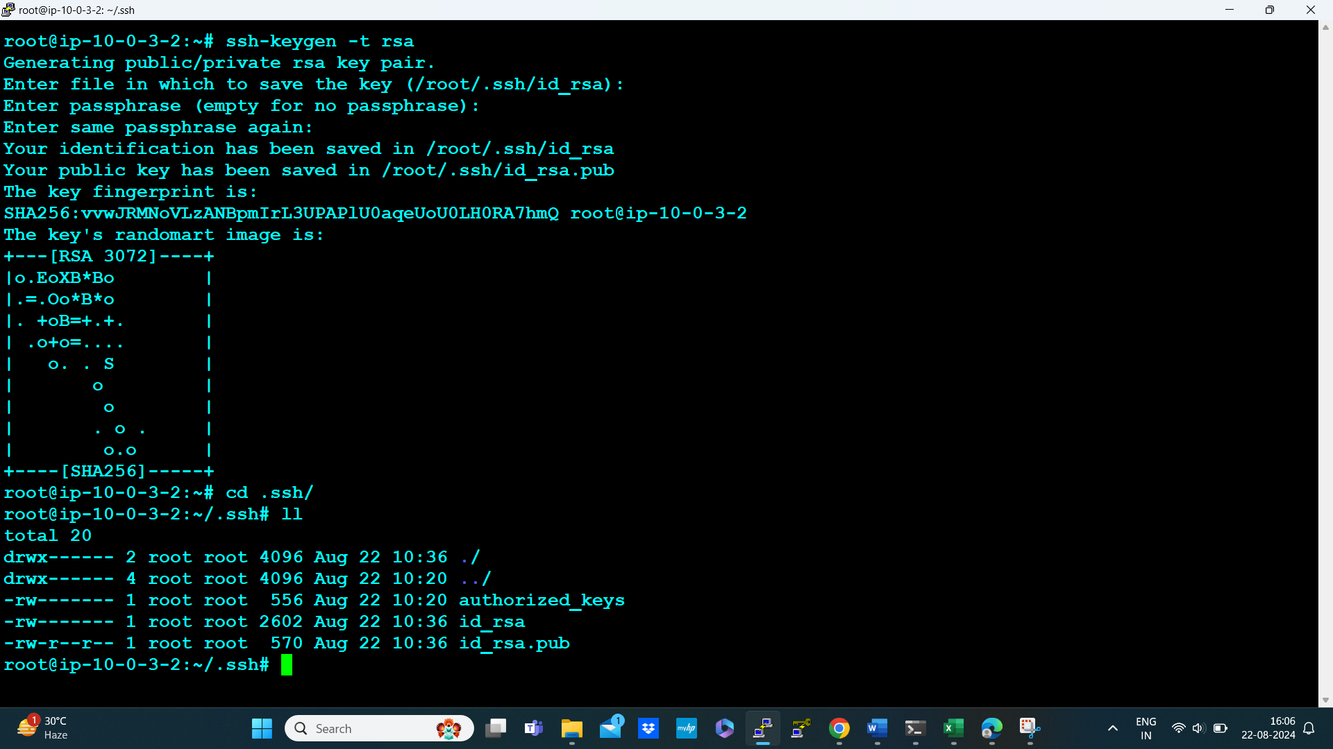

Install kops in the management-server

# curl -LO https://github.com/kubernetes/kops/releases/download/$(curl -s https://api.github.com/repos/kubernetes/kops/releases/latest | grep tag_name | cut -d '"' -f 4)/kops-linux-amd64

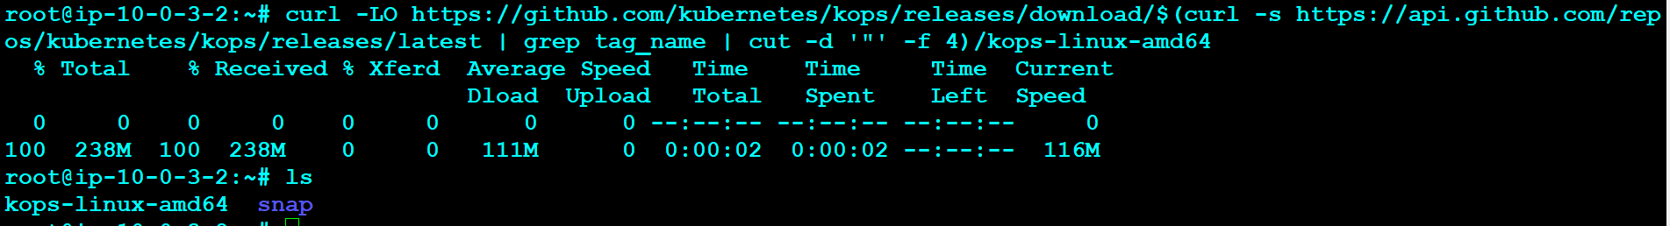

Then provide executable permission

# chmod +x kops-linux-amd64

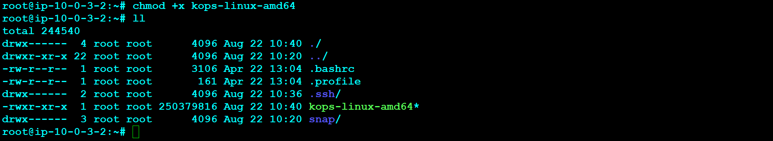

Move kops-linux-amd64 to the directory /usr/local/bin

# sudo mv kops-linux-amd64 /usr/local/bin

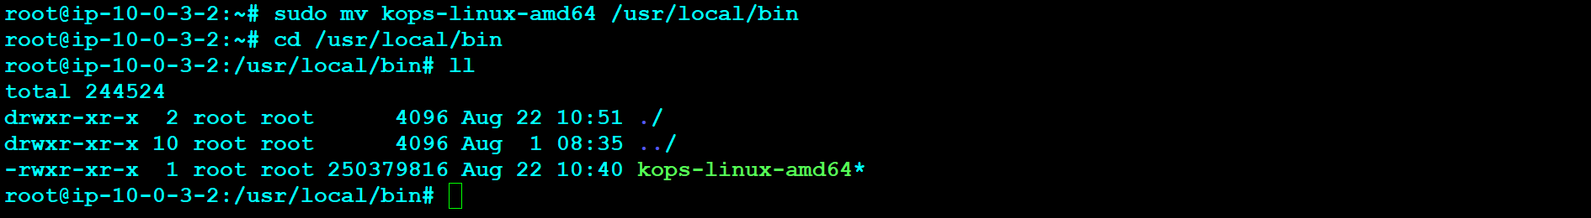

# snap install kops

Now check the version of kops the command is # kops version

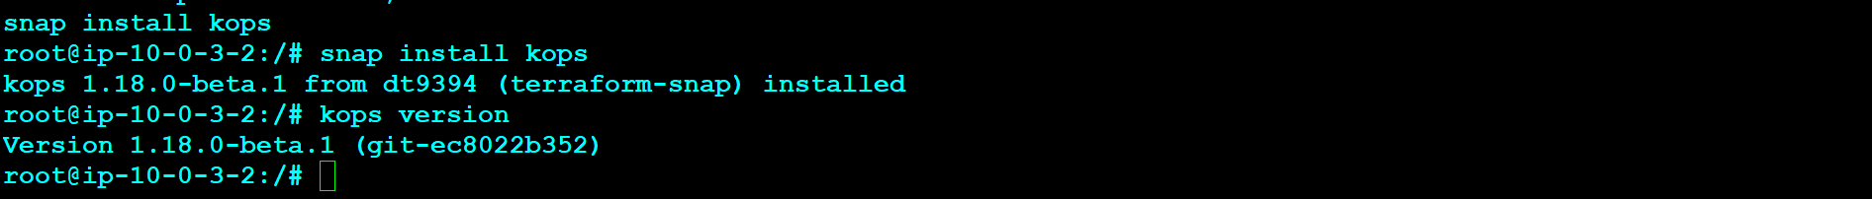

Then install kubectl

# curl -LO "https://dl.k8s.io/release/**$(**curl -L -s https://dl.k8s.io/release/stable.txt**)**/bin/linux/amd64/kubectl"

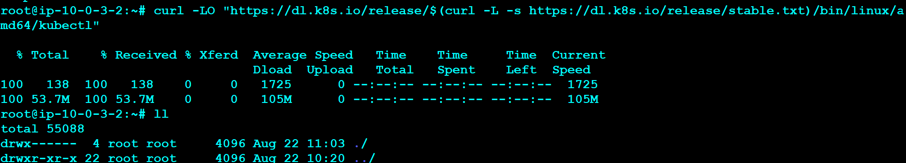

Provide executable permission

# chmod +x kubectl

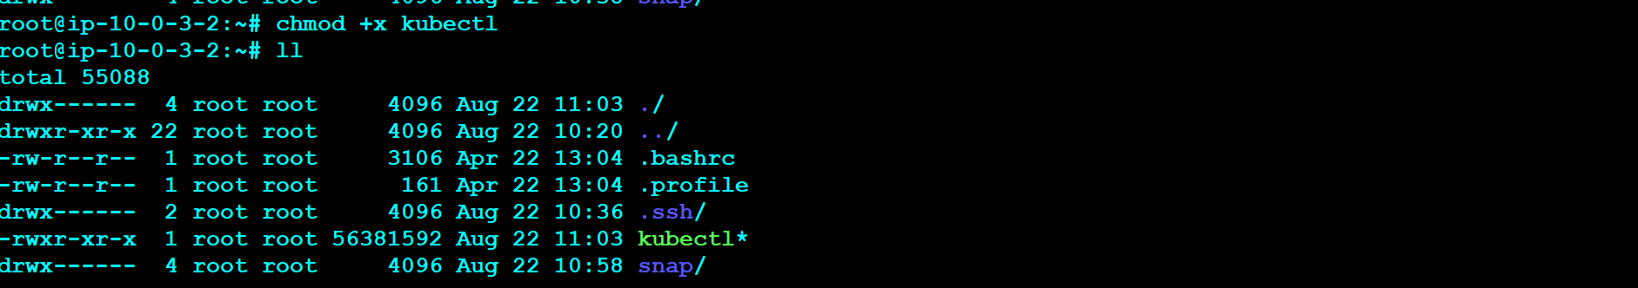

Then move to the /usr/local/bin

# mv /usr/local/bin

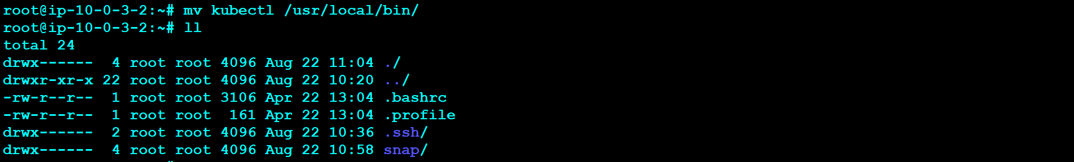

Then check kubectl version



Creating the k8s cluster using the below commands

kops create cluster --name=spovedsys.shop \

--state=s3://spovedsys.shop \

--zones=us-east-1a,us-east-1b \

--node-count=2 \

--control-plane-count=1 \

--node-size=t3.medium \

--control-plane-size=t3.medium \

--control-plane-zones=us-east-1a \

--control-plane-volume-size=10 \

--node-volume-size=10 \

--ssh-public-key=~/.ssh/id_rsa.pub \

--networking=calico \

--dns-zone=spovedsys.shop \

--yes

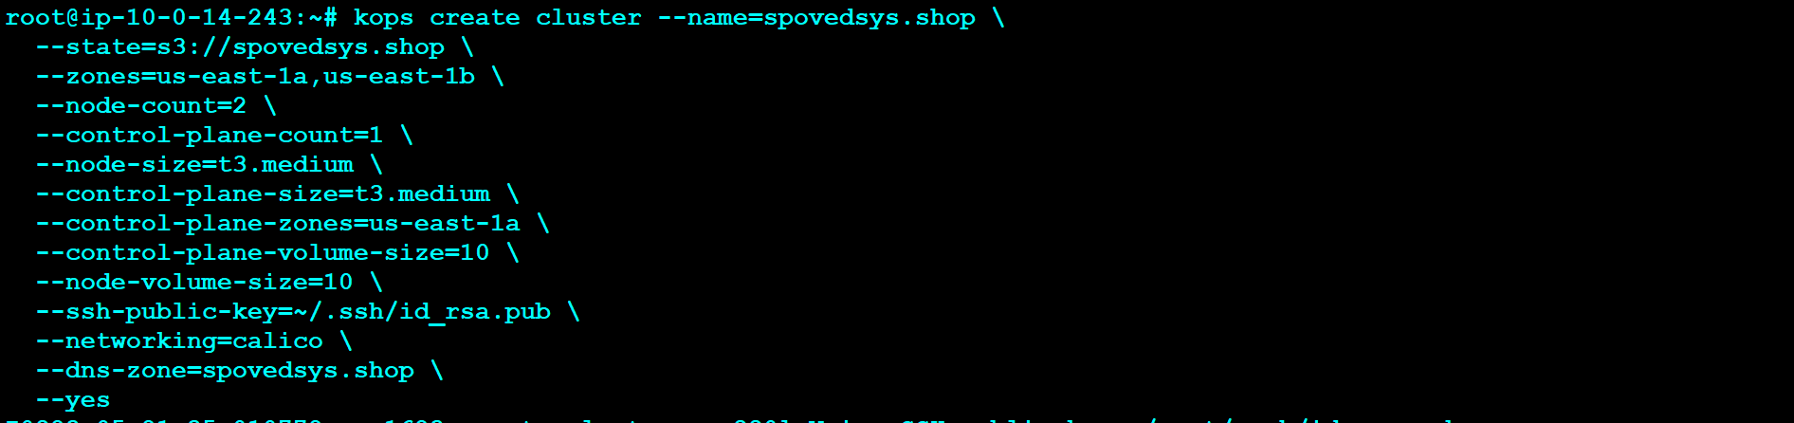

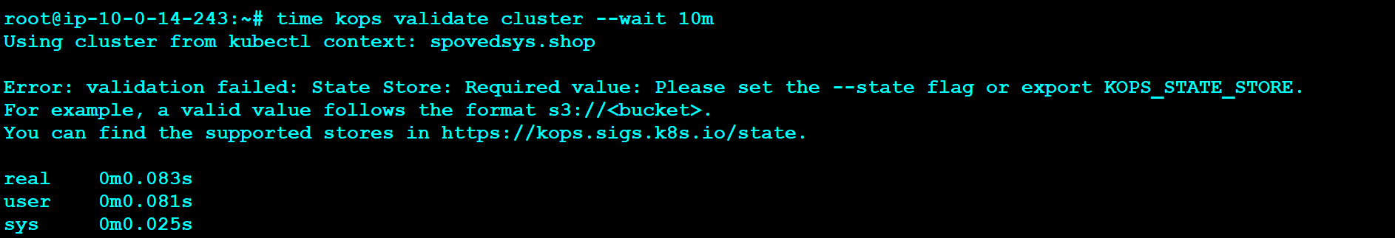

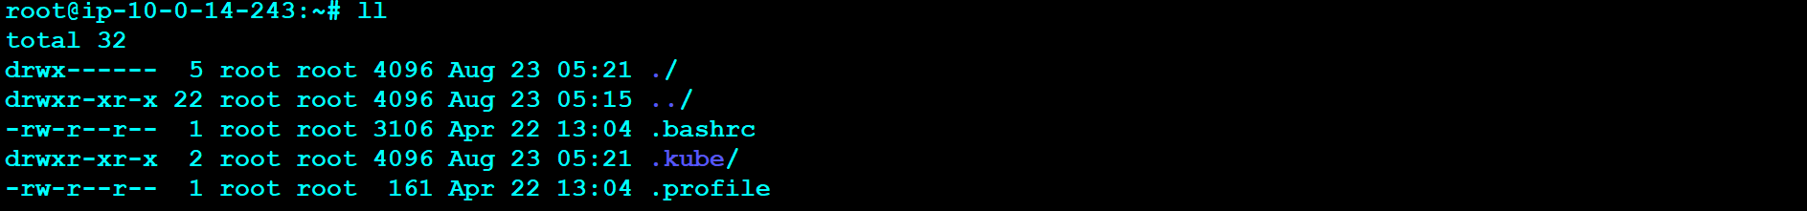

vi .bashrc 🡪inside this folder past the following commands

export CLUSTER_NAME=spovedsys.shop

export AWS_REGION=us-east-1

export NAME=spovedsys.shop

export KOPS_STATE_STORE=s3://spovedsys.shop

## Adding Aliases

alias ku=kubectl

alias pods='kubectl get pods -A'

alias pots='kubectl get pods'

alias deploy='kubectl get deployment'

alias svc='kubectl get svc'

alias nodes='kubectl get nodes'

alias ns='kubectl get ns'

echo 'source <(kubectl completion bash)' >>~/.bashrc

echo 'alias ku=kubectl' >>~/.bashrc

echo 'complete -o default -F __start_kubectl ku' >>~/.bashrc

source ~/.bashrc

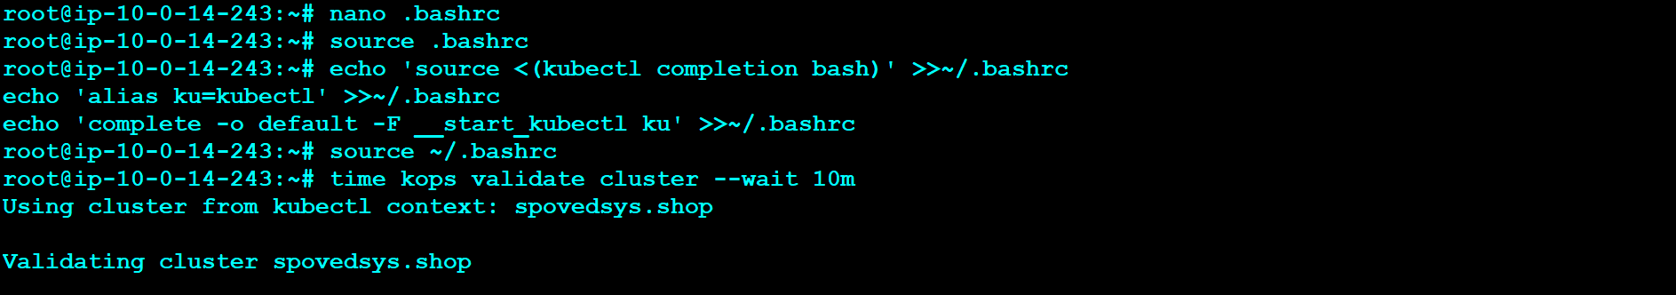

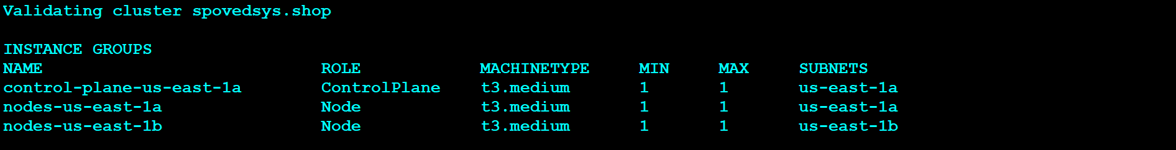

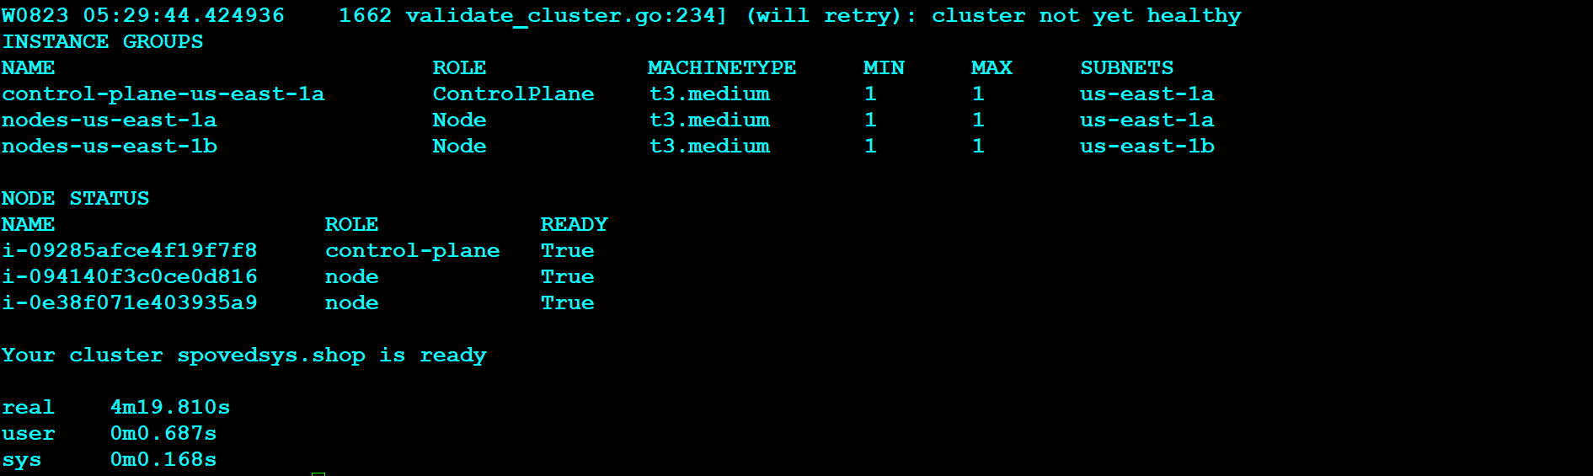

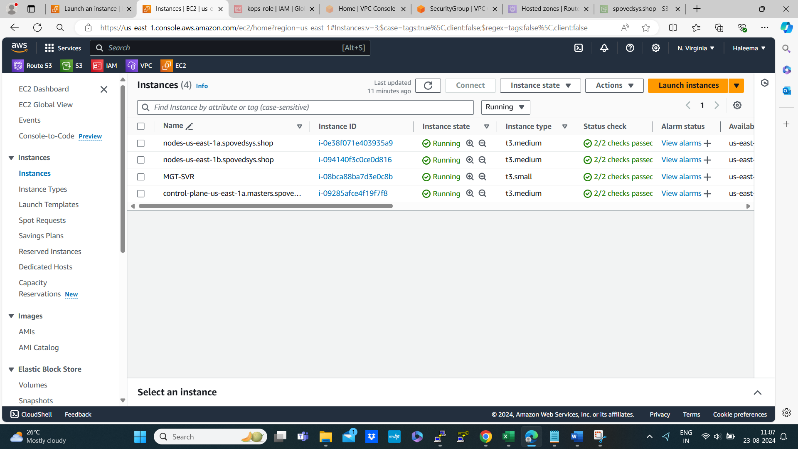

Then install Lens from Google

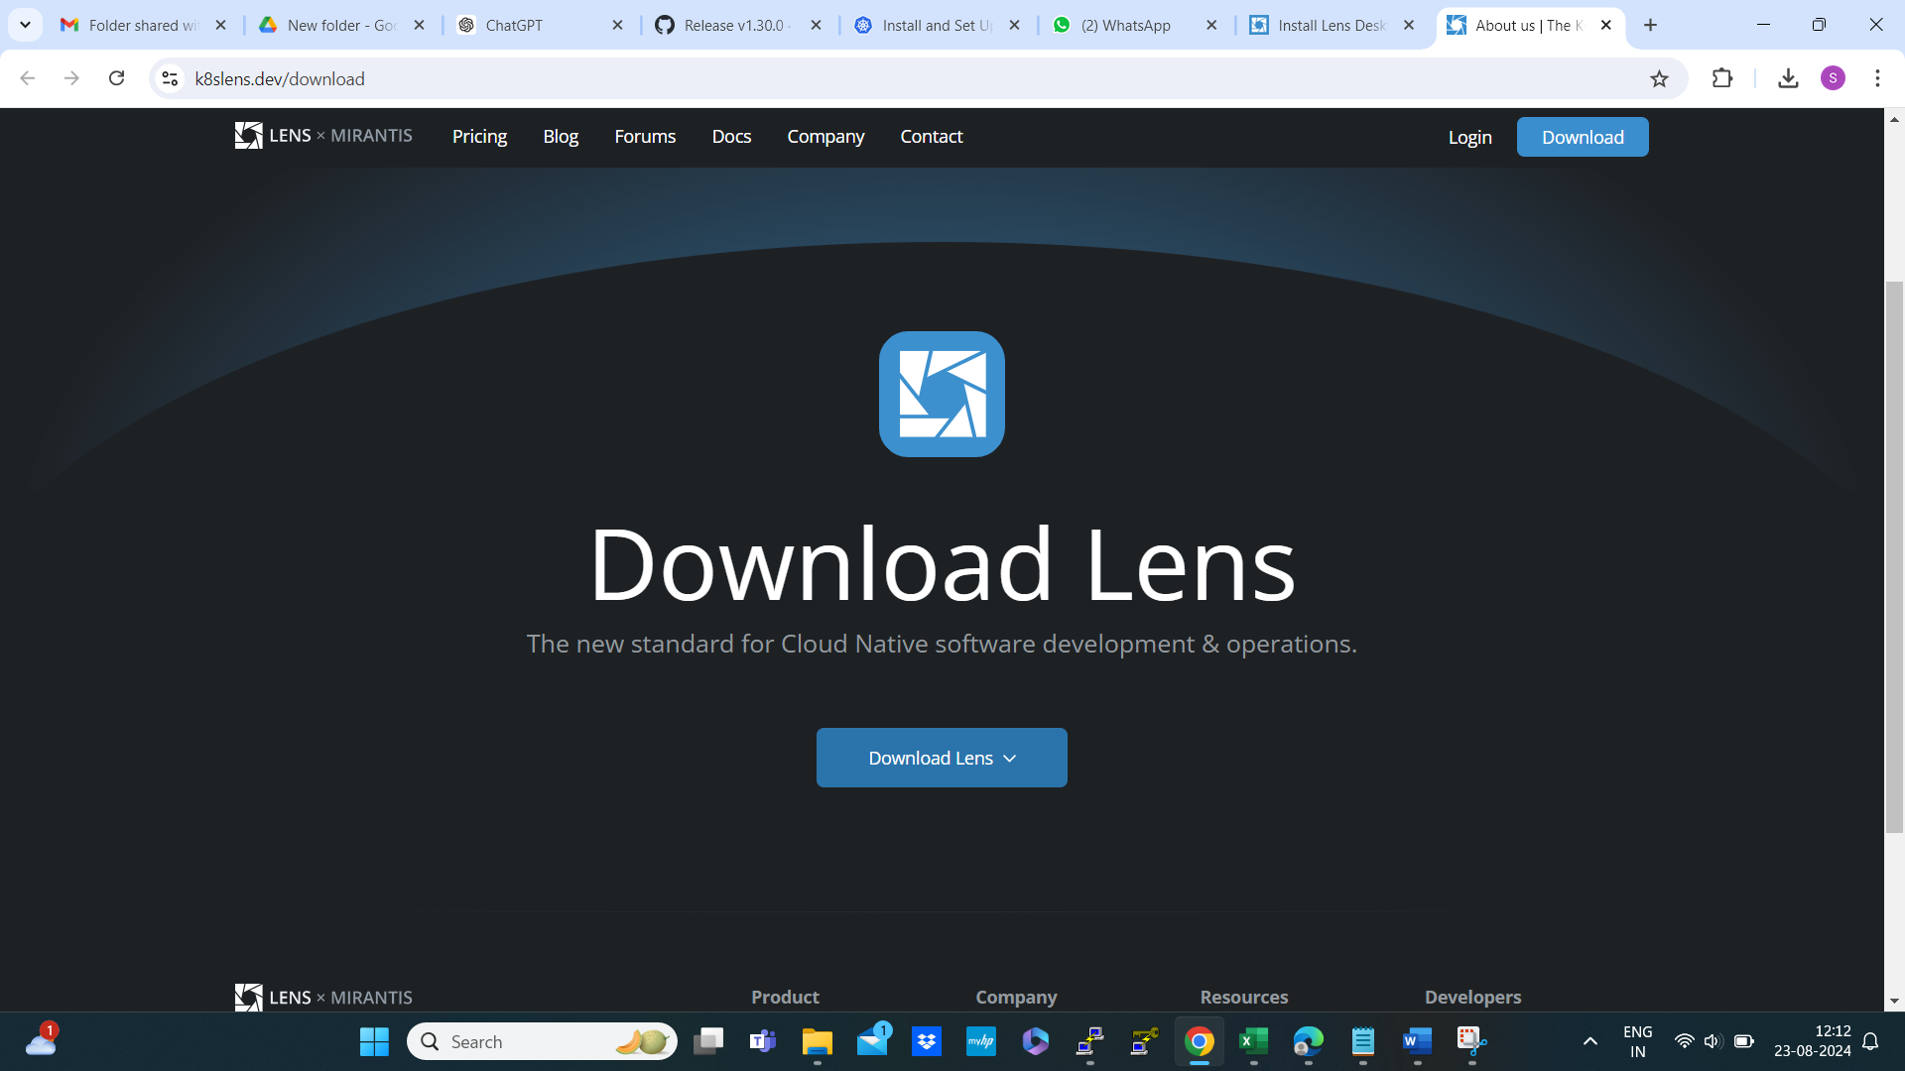

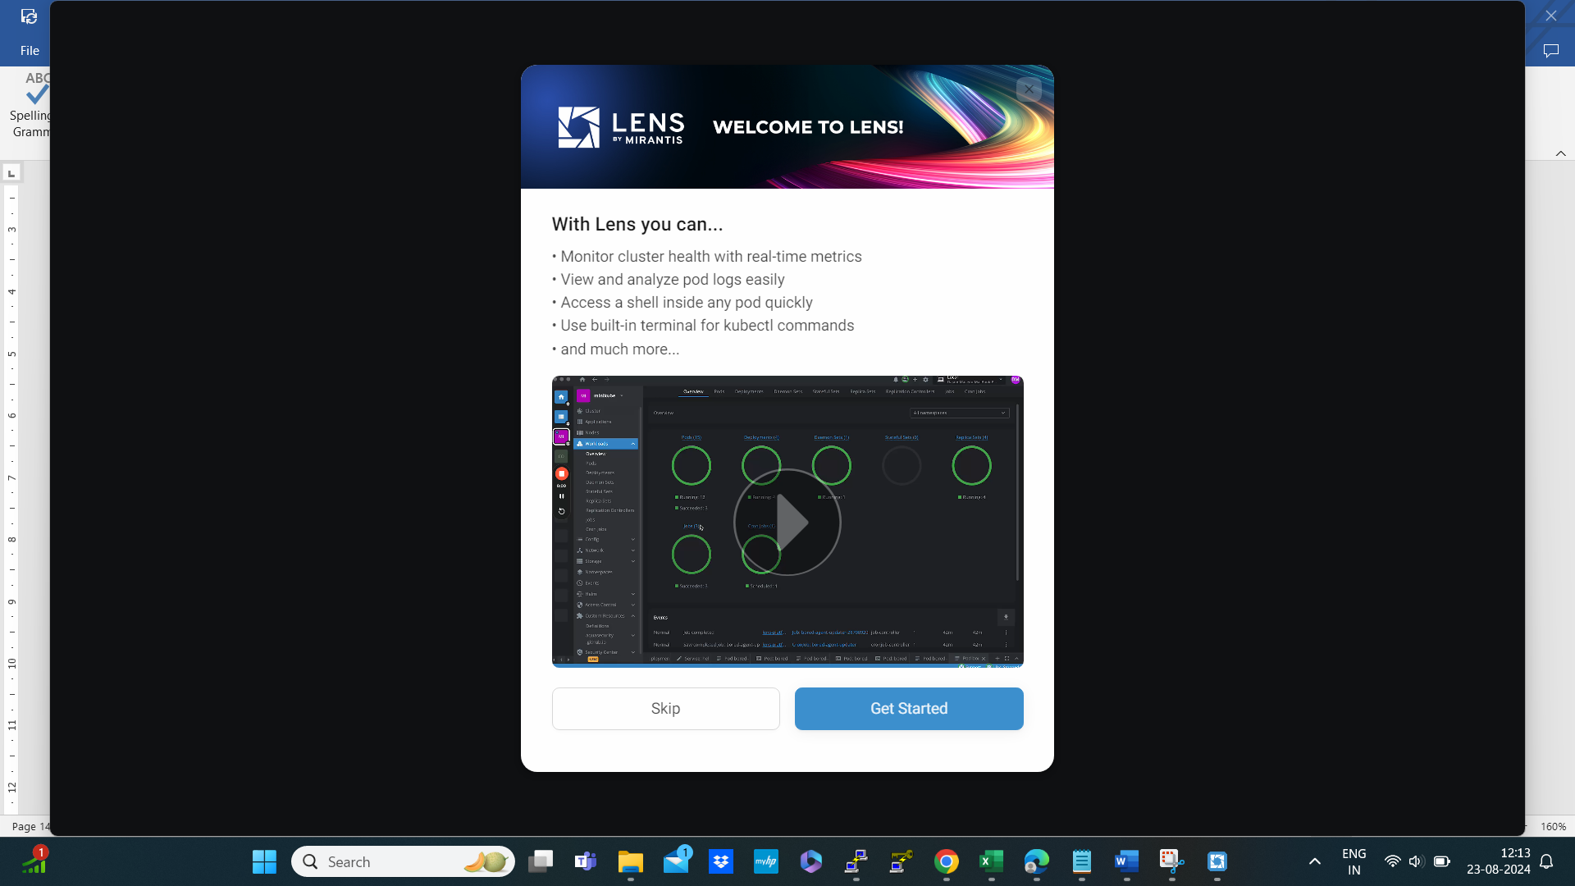

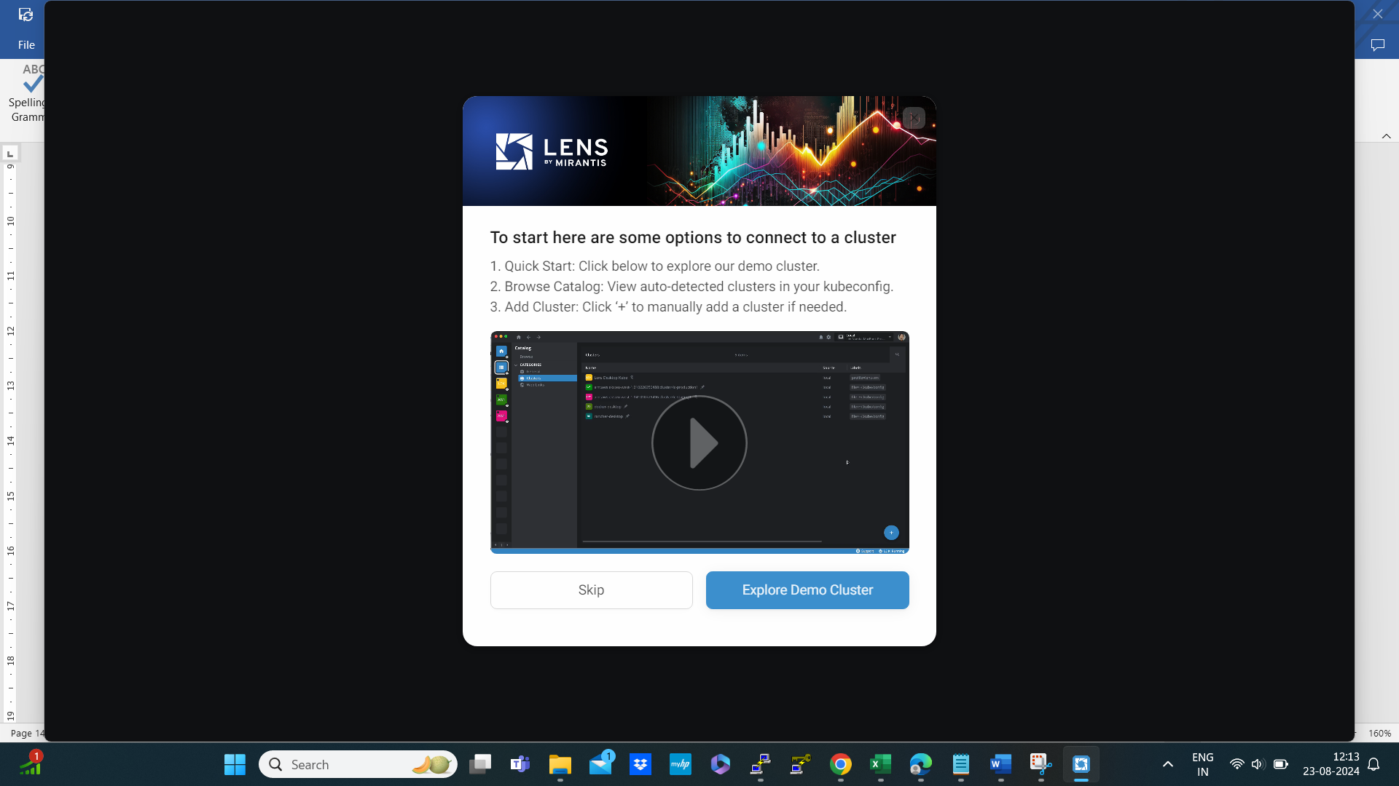

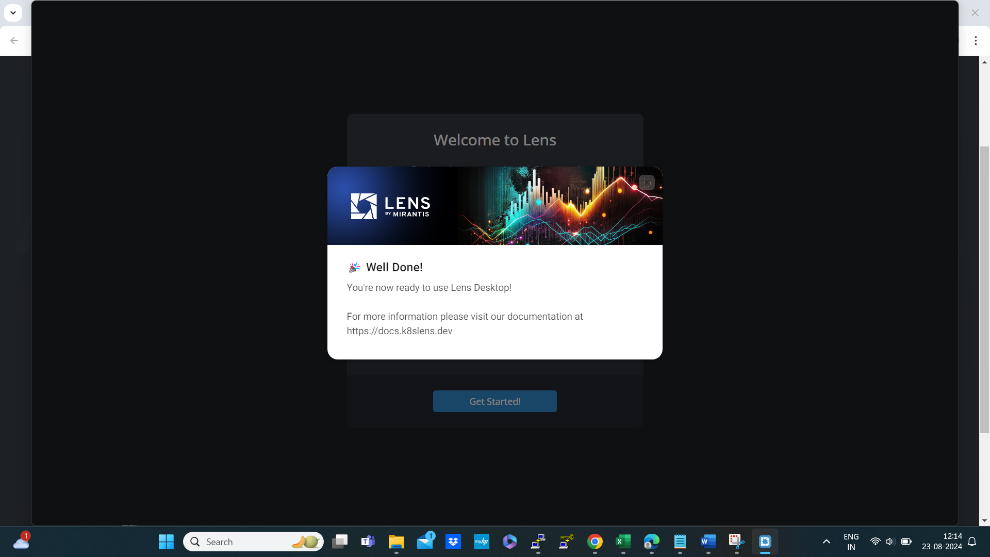

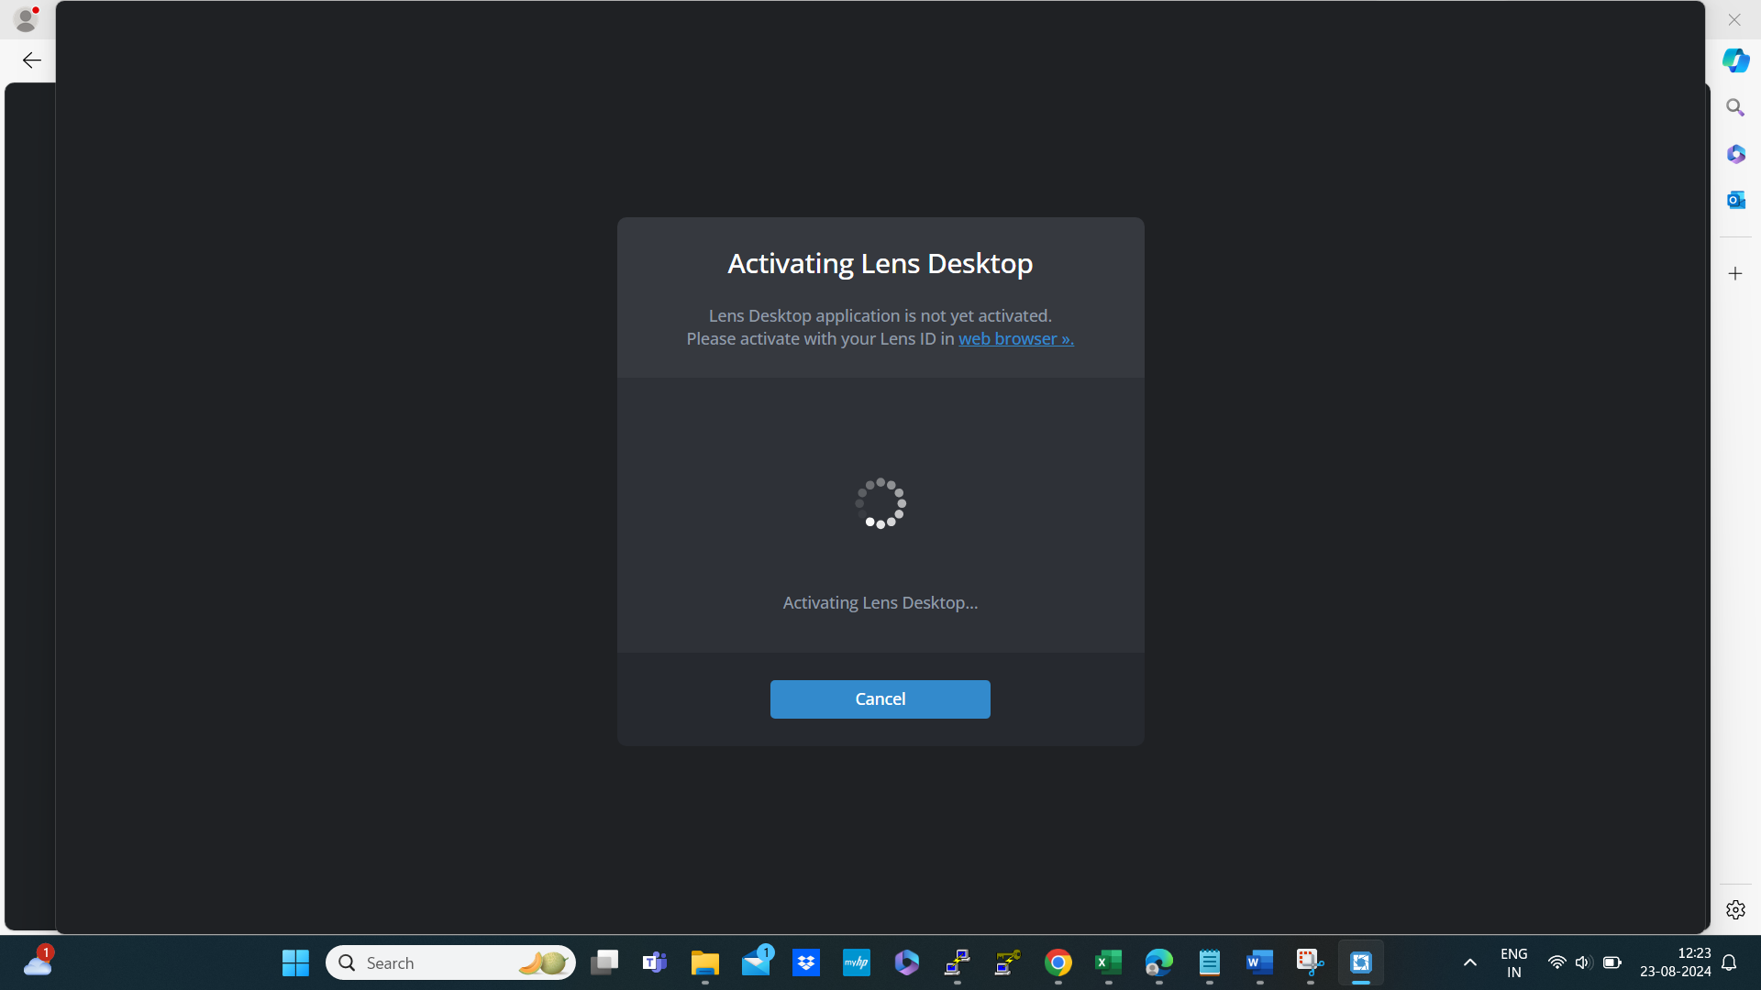

Go to the three horizontal line 🡪 add cluster 🡪 past kubectl config key

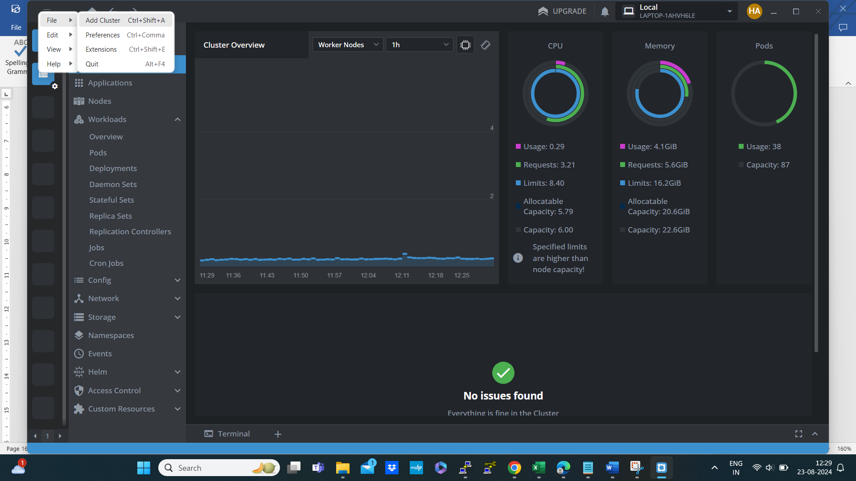

Past the kube config here

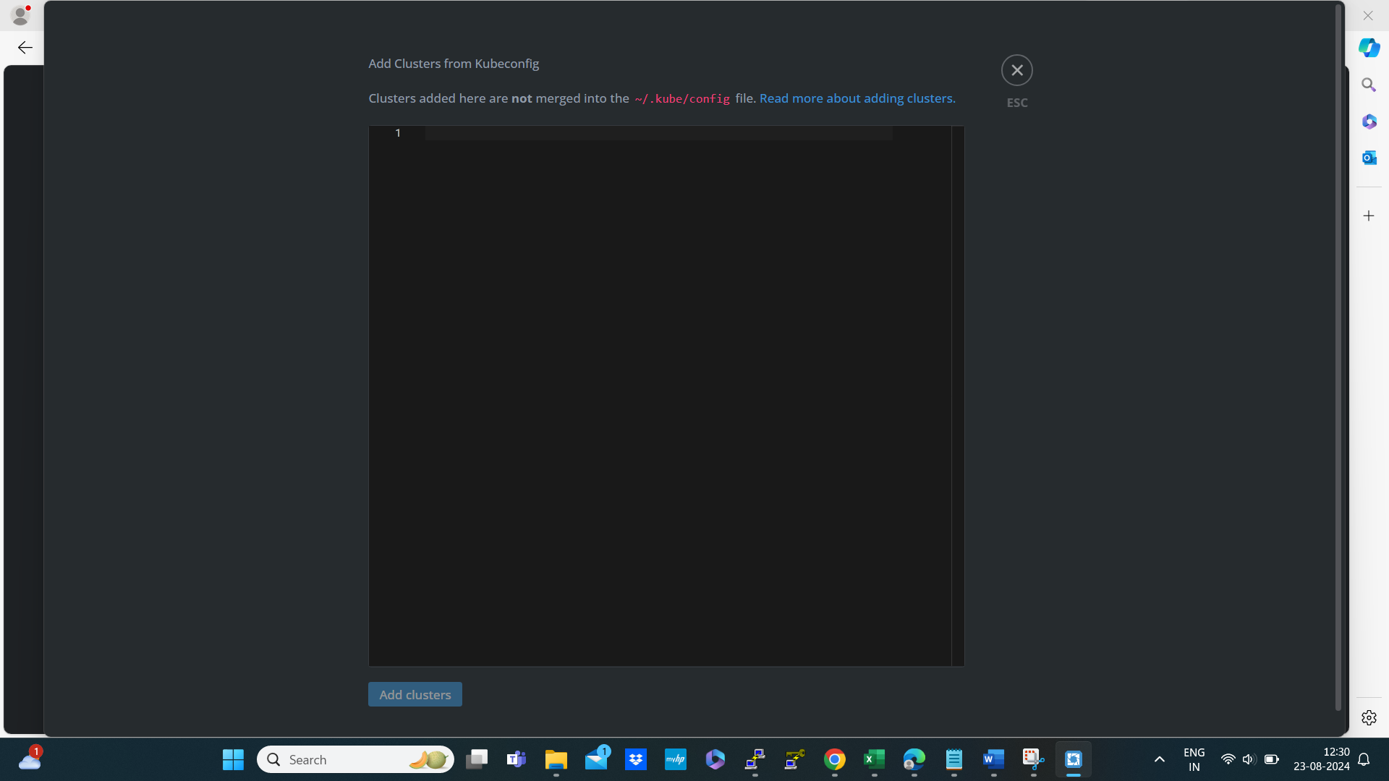

To find out the key

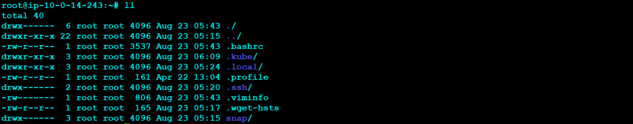

Then cd .kube inside it a config file present in that file that key occur copy that key and past it that’s it you can see all the GUI of the Kubernetes cluster

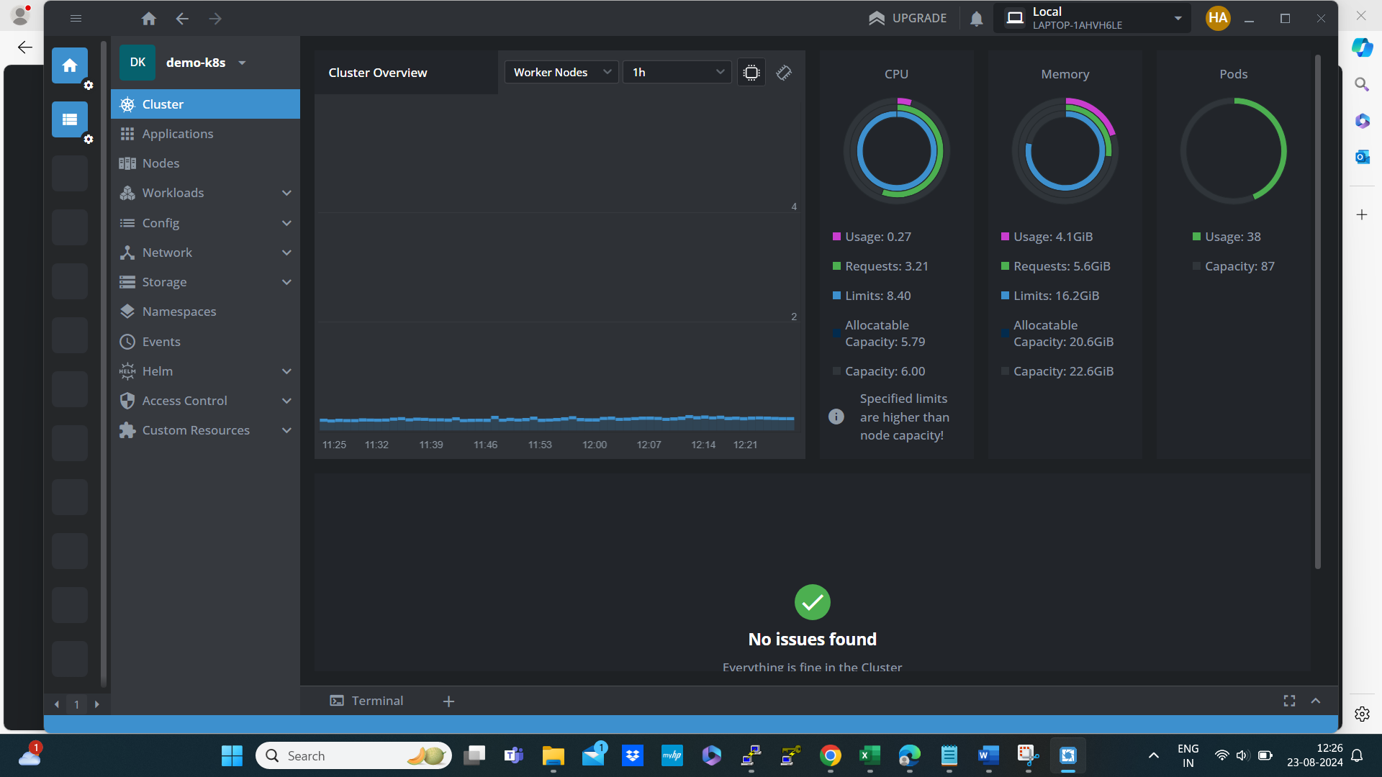

After completion of work with our cluster. we can delete clusters by using the

below command.

$ kops delete cluster --name=spovedsys.shop --state=s3://spovedsys.shop –yes





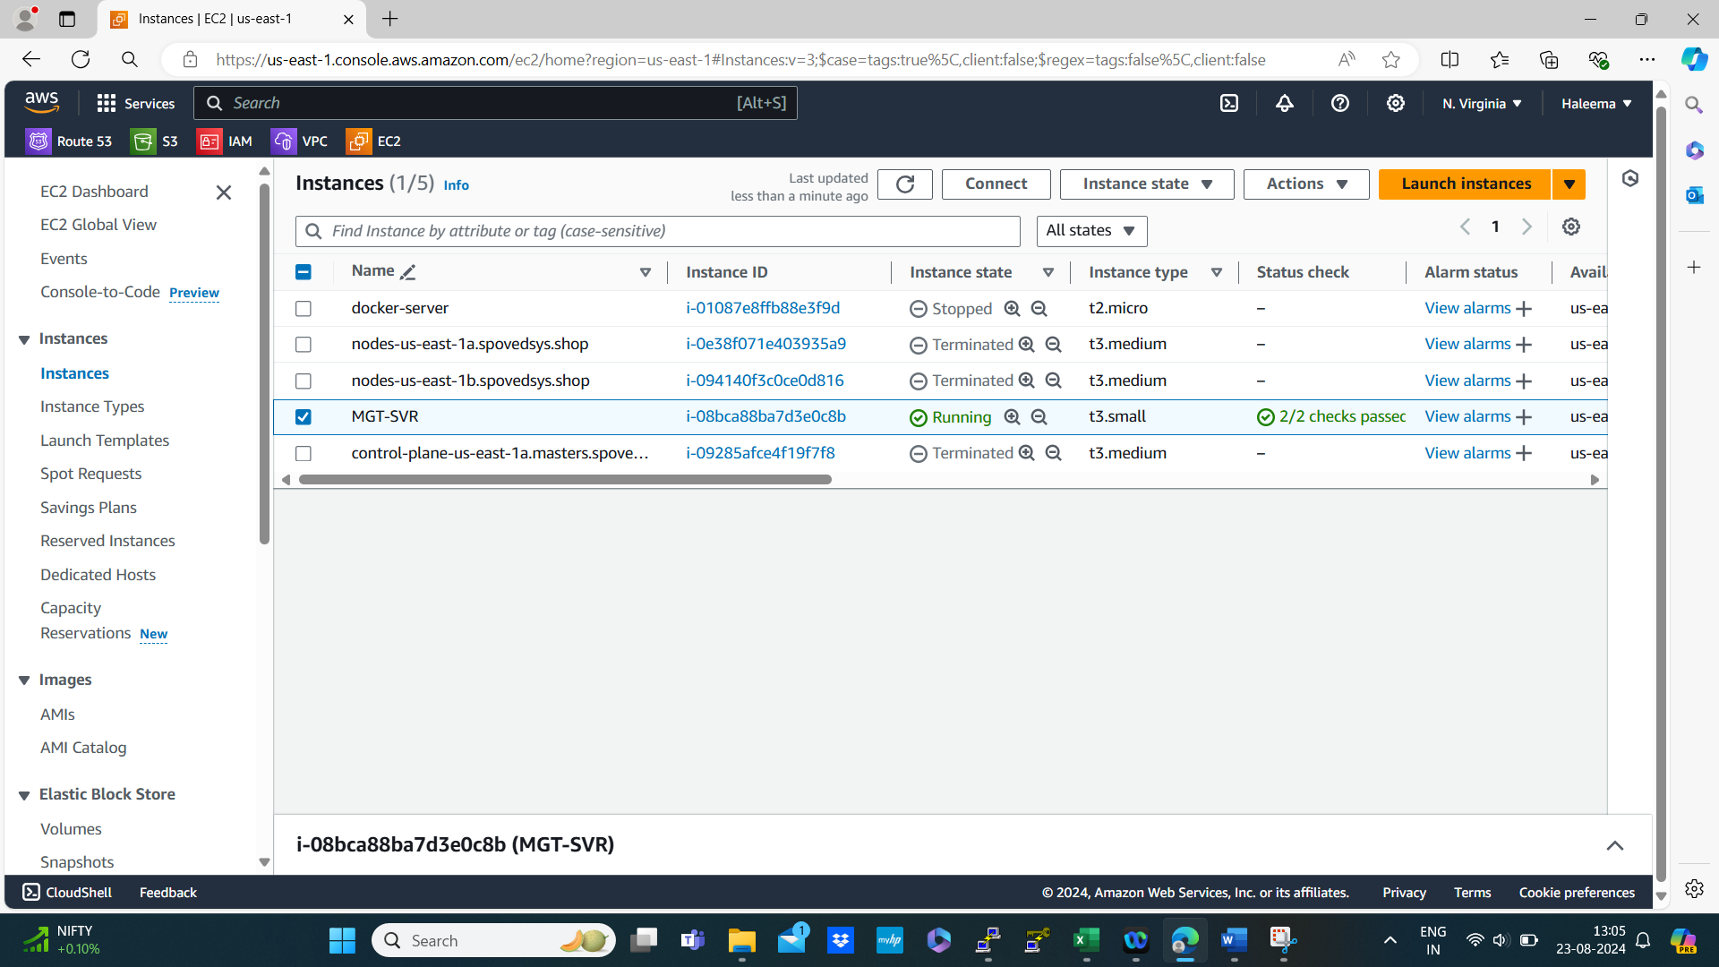

Manually terminate MGT-SVR to avoid charges

